Auto Scaling group

1. Create an ec2 instance . Make it up and running
2. Create image of instance

Action🡺image and template🡺 create image

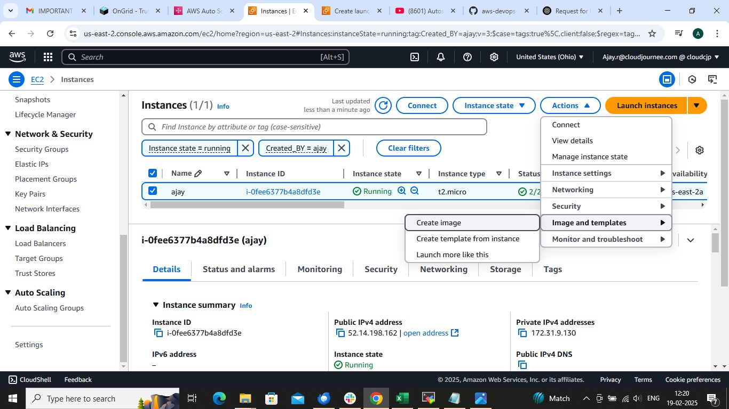

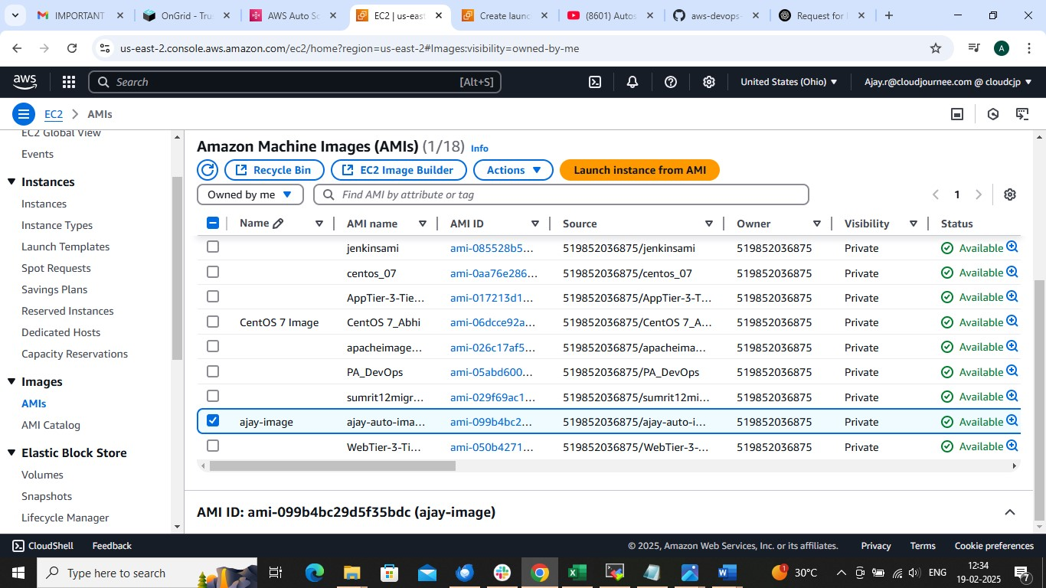

On Ec2 dashboard left side 🡺 ASG 🡺 Create ASG

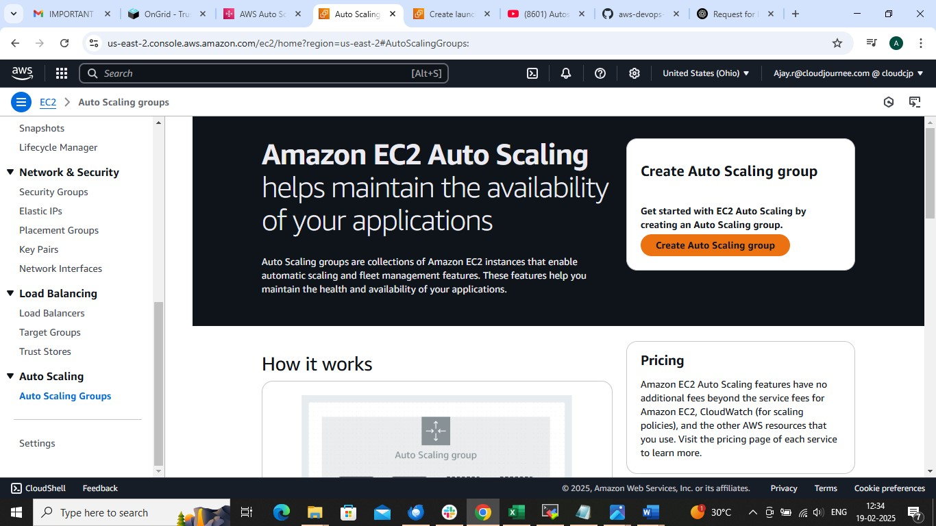

Create ASG name and =🡺 launch template

Create launch template name

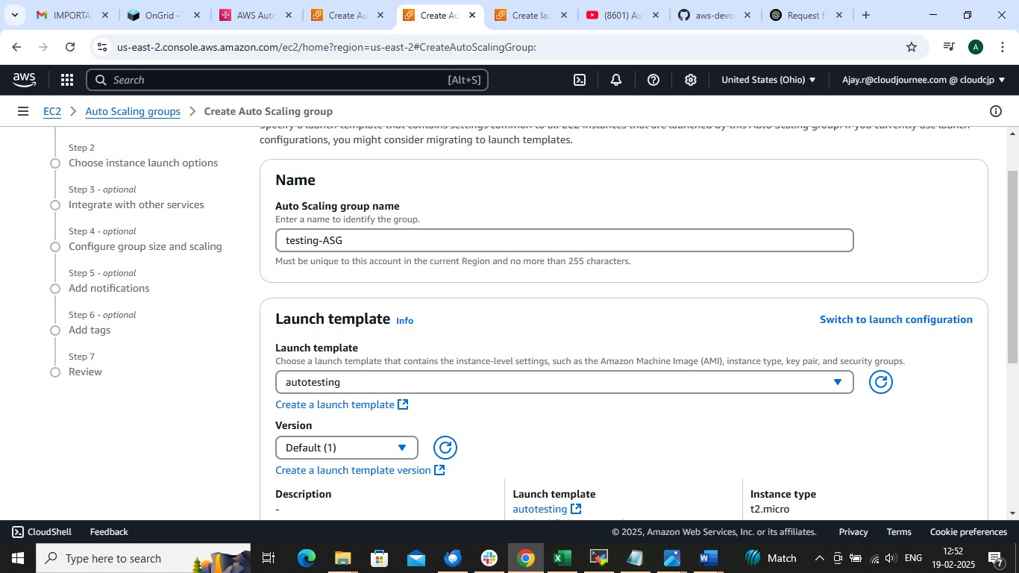

🡺Choose Created image OR IF YOU HAVE NOT CREATED IMAGE THEN USE GIVEN AMI IMAGE FROM BELOW LIKE UBUNTU

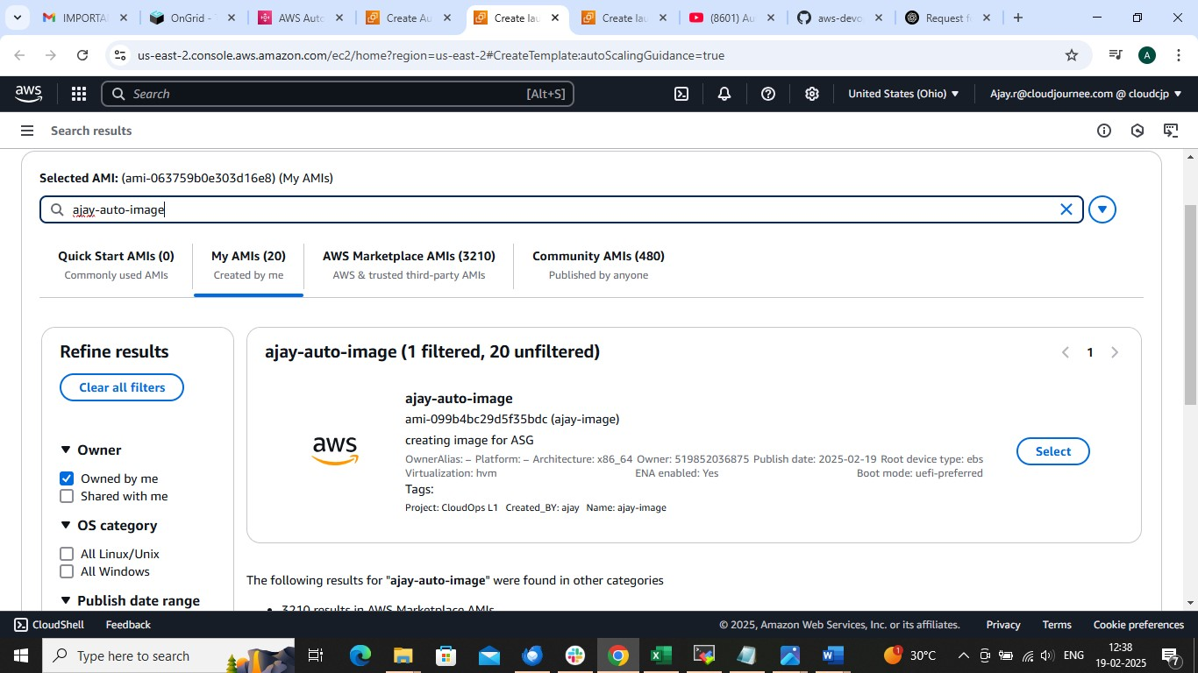

CHOOSE PROPERE INSTANCE TYPE

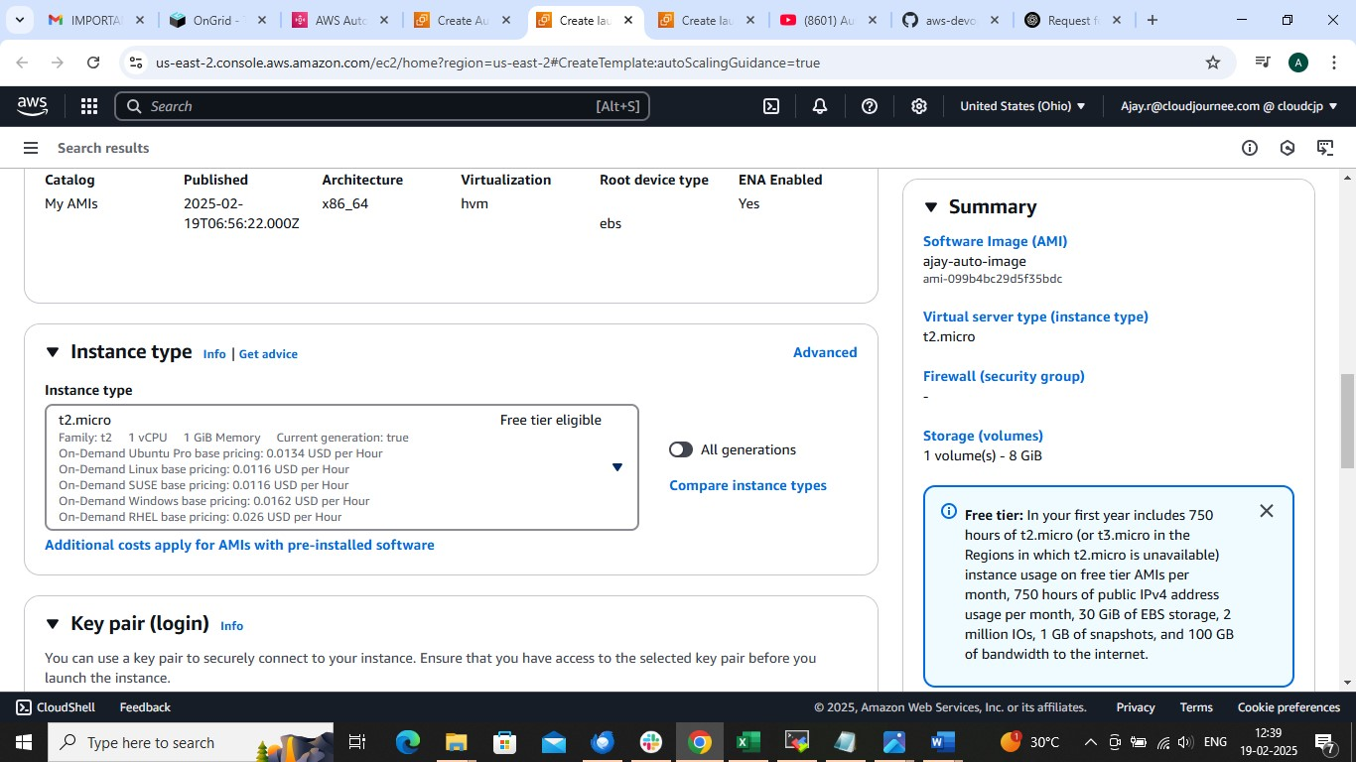

FOLLOW FOLLOWIMG STEPS AND 🡺 LAUNCH TEMPLATE

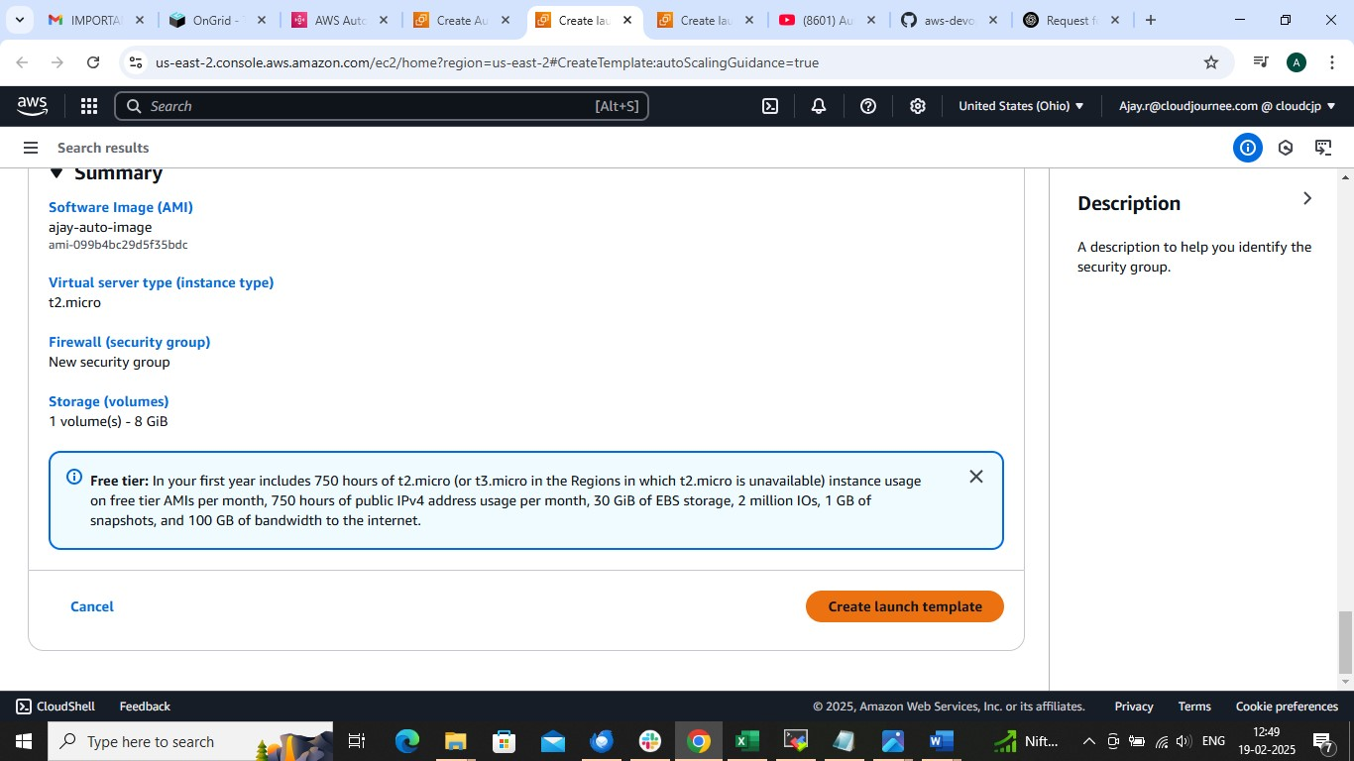

Go to ASG page and choose TEMPLATE



Choose VPC and subnet

CHOOSE 2 T0 3 SUBNETS

IF HAVE CREATED THEN CHOOSE OR CHOOSE DEFAULT ONE

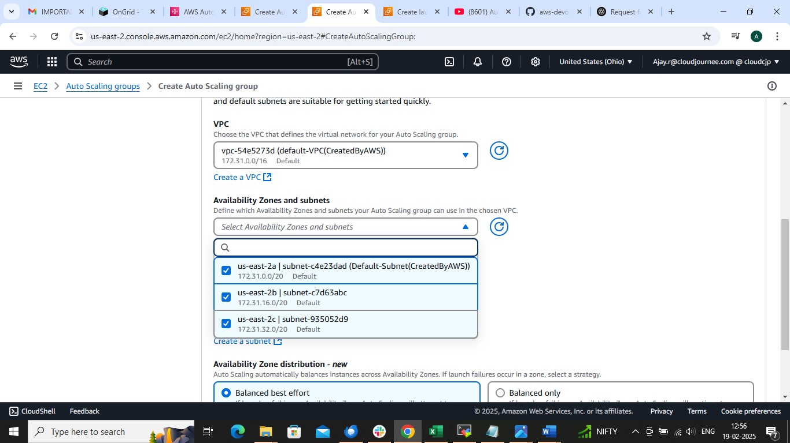

Check for ec2 health and put HEALTH GRACE PERIOD TO 60SEC

IT WILL AUTOMATICALLY REMOVE UNHEALTHY INSTANCE WITH HEALTHY ONE AG

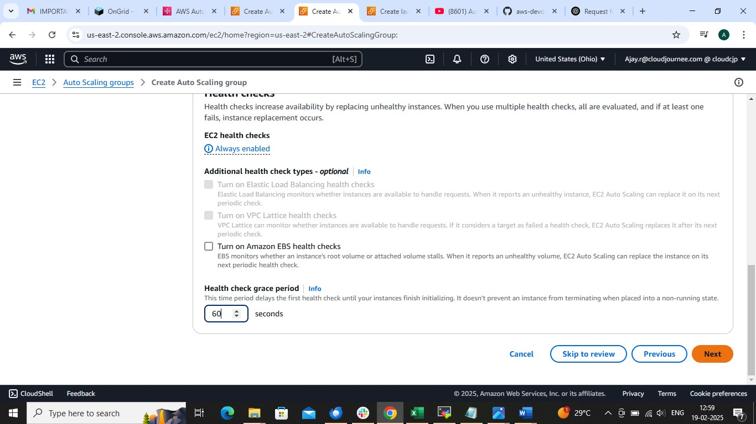

Configure max and min and desires number of instances

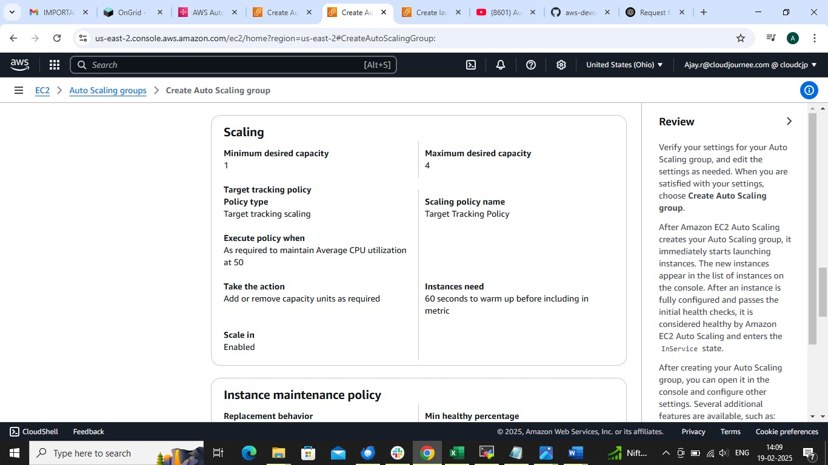

CHOOSE TARGET TRACKING SCALING AND SET CPU UTILIZATION 50

IT WILL AUTOMATICALLY INCREASE OR DECREASE INSTANCES BASED ON CUP UTILIZATION

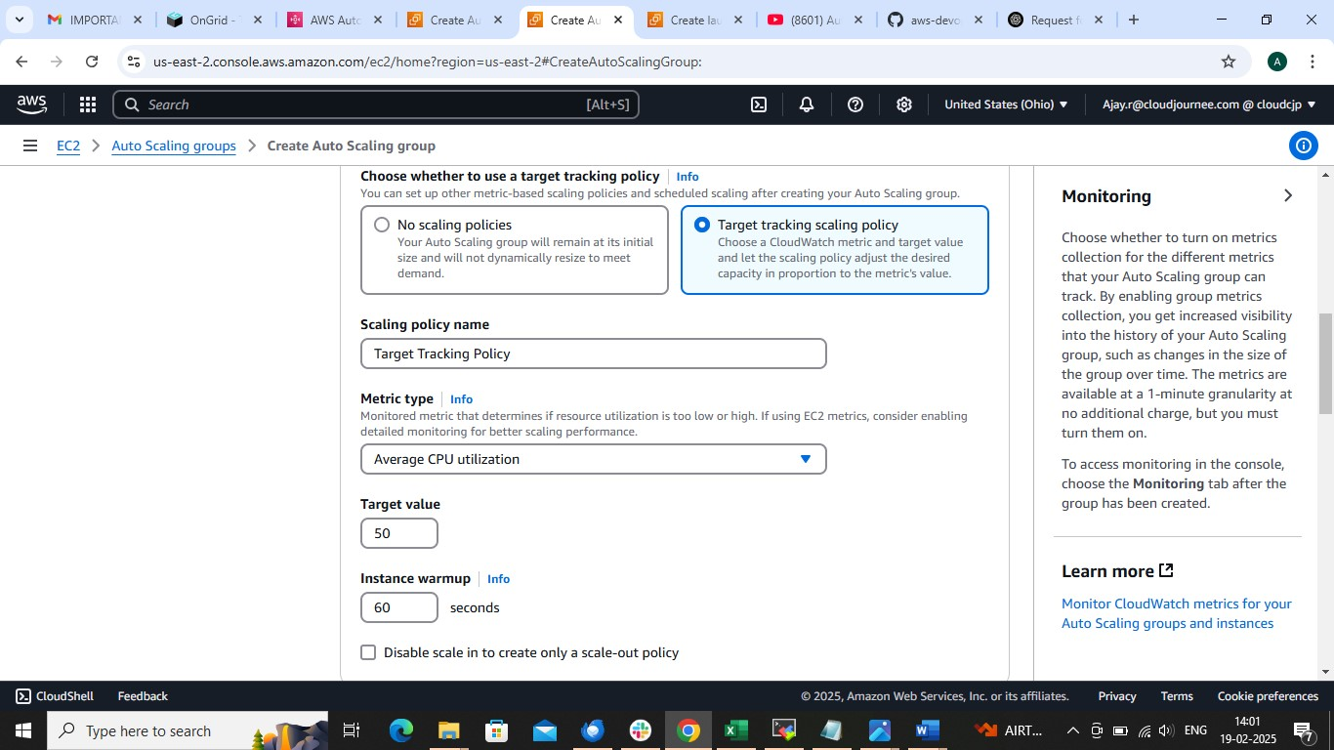

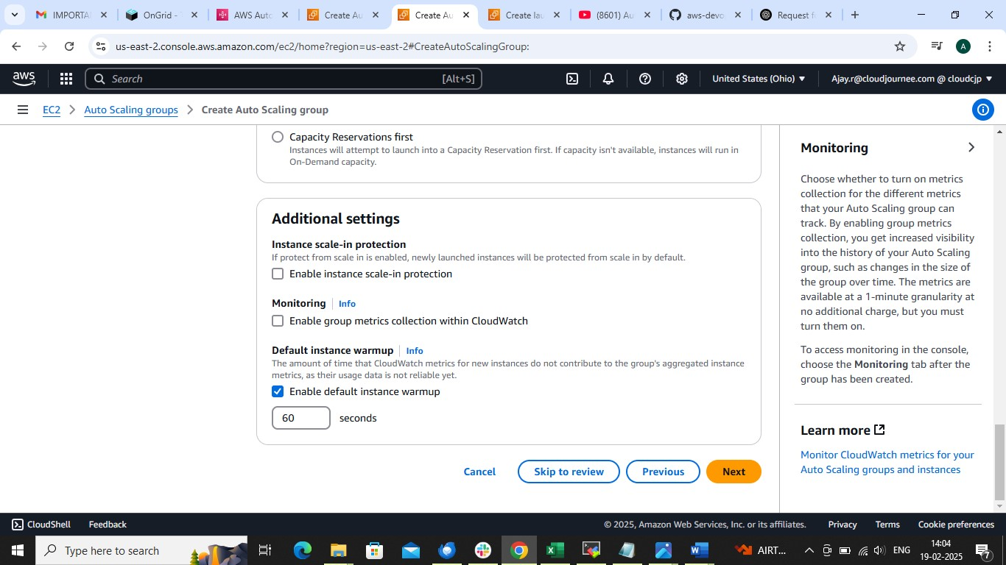

REVIEW AND CREATE

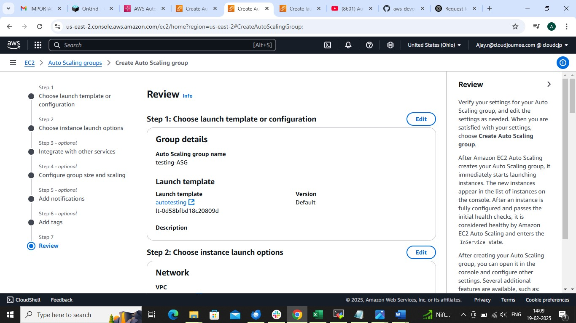

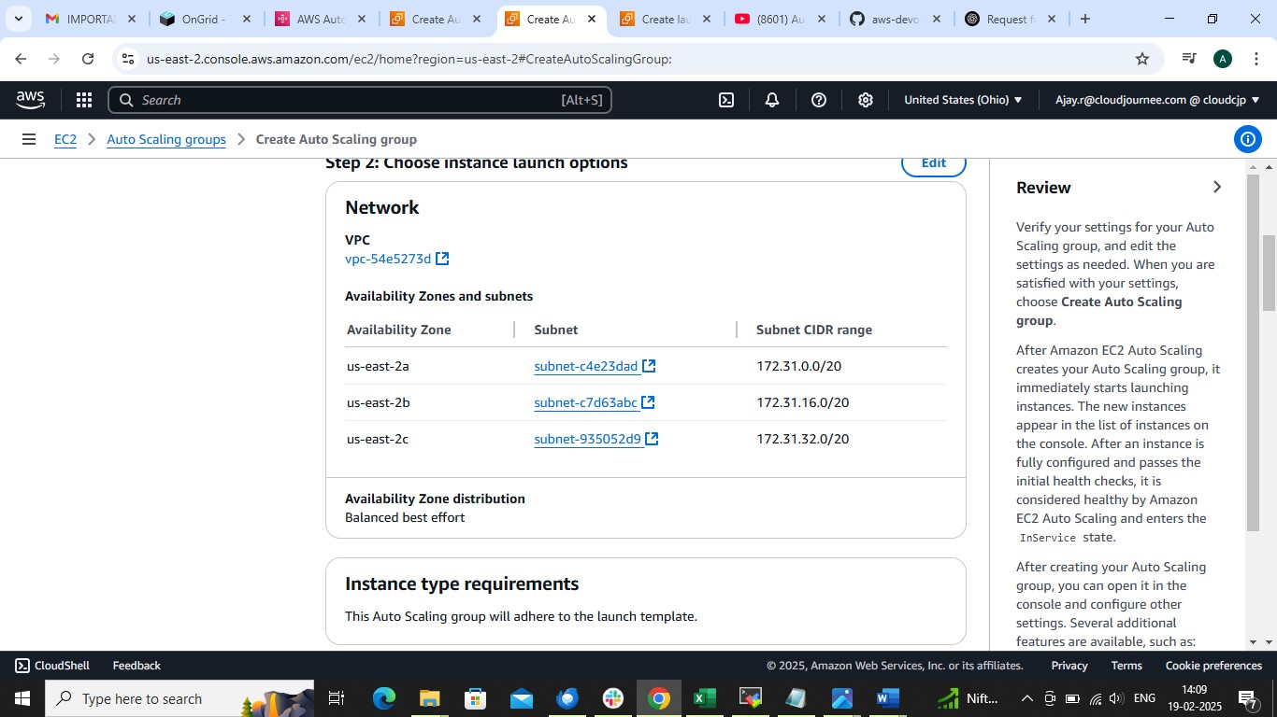

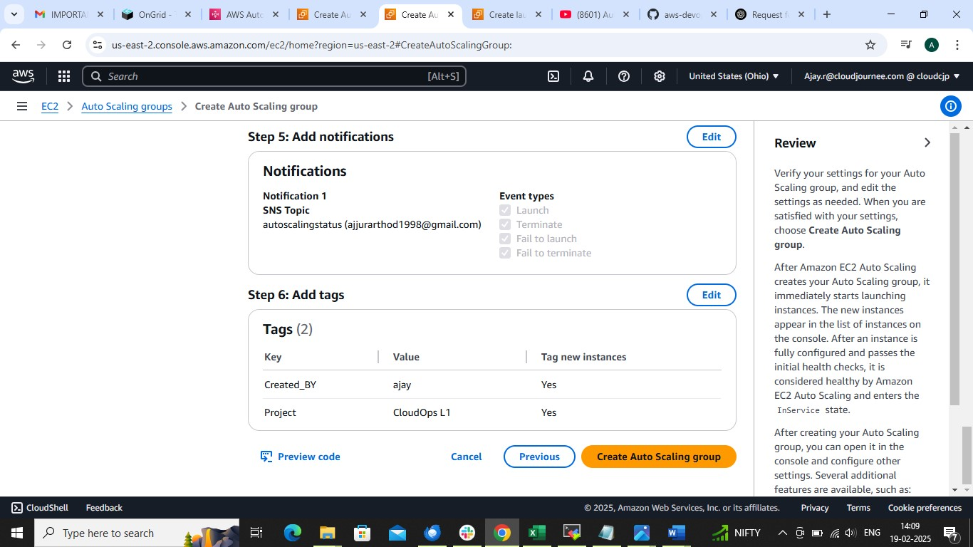

SEE THE RESULT

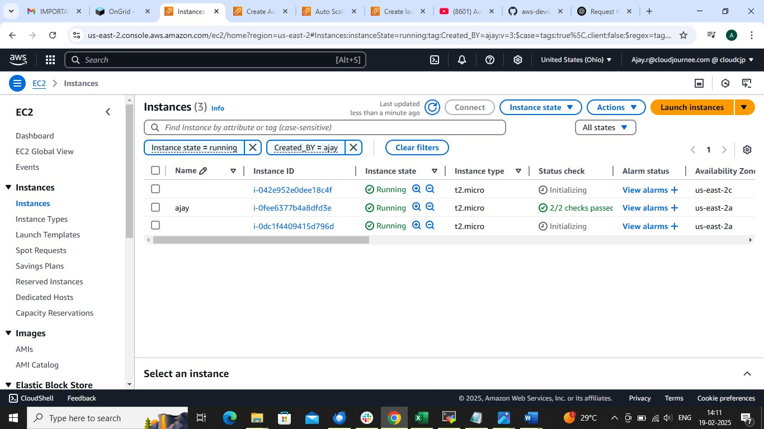

AFTER THIS 🡺ASG , In details section 🡺edit load balancer 🡺add existing load balancer or create NEW Lb AND ADD TARGET GROUP AND SAVE

I AM GOING CHOOSE EXISTING ONE BCZ I HAVE ALREADY CREATED ONE ..REFER LOAD BALANCER FILE FOR MORE DETAILS

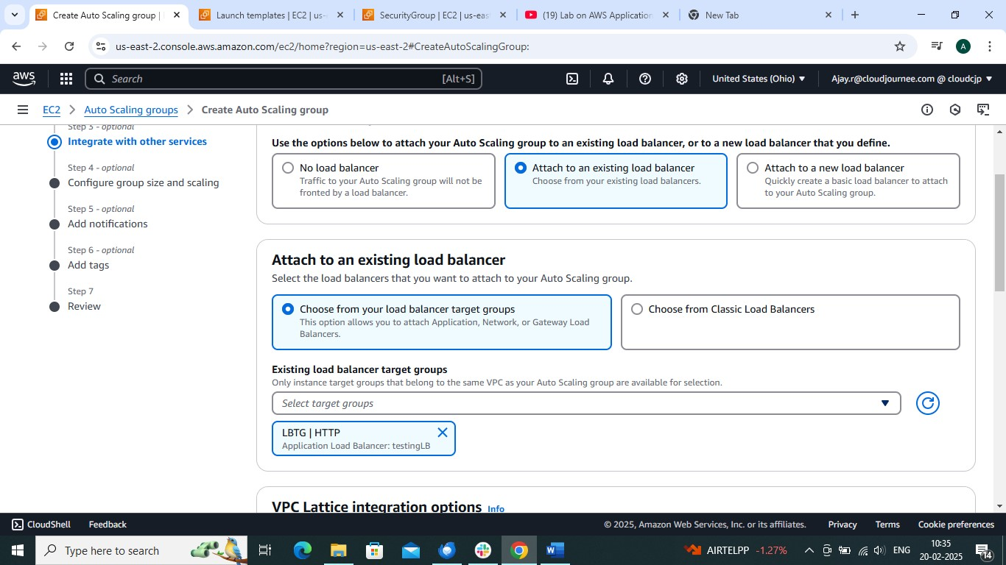

Now go to load balancer and select load balancer and copy DNS PATH

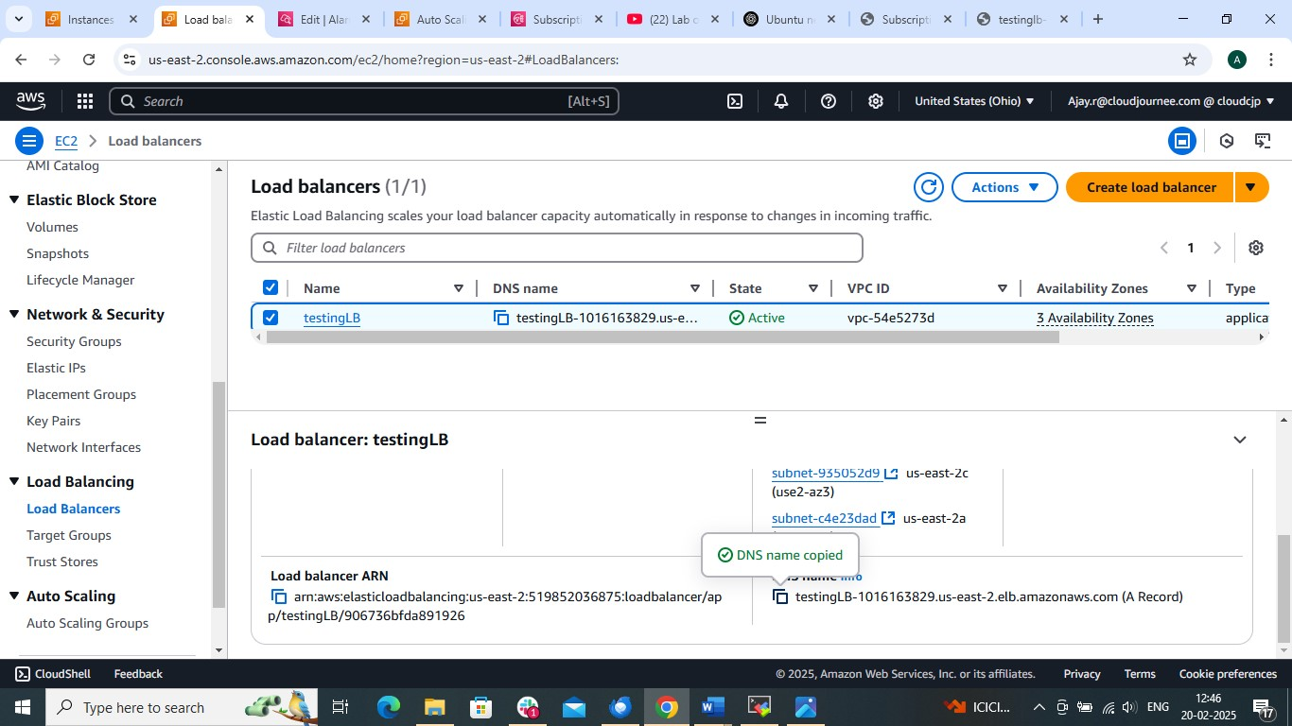

COPY AND PASTE DNS PATH IN BROWSER BY REMOVING S FROM PATH

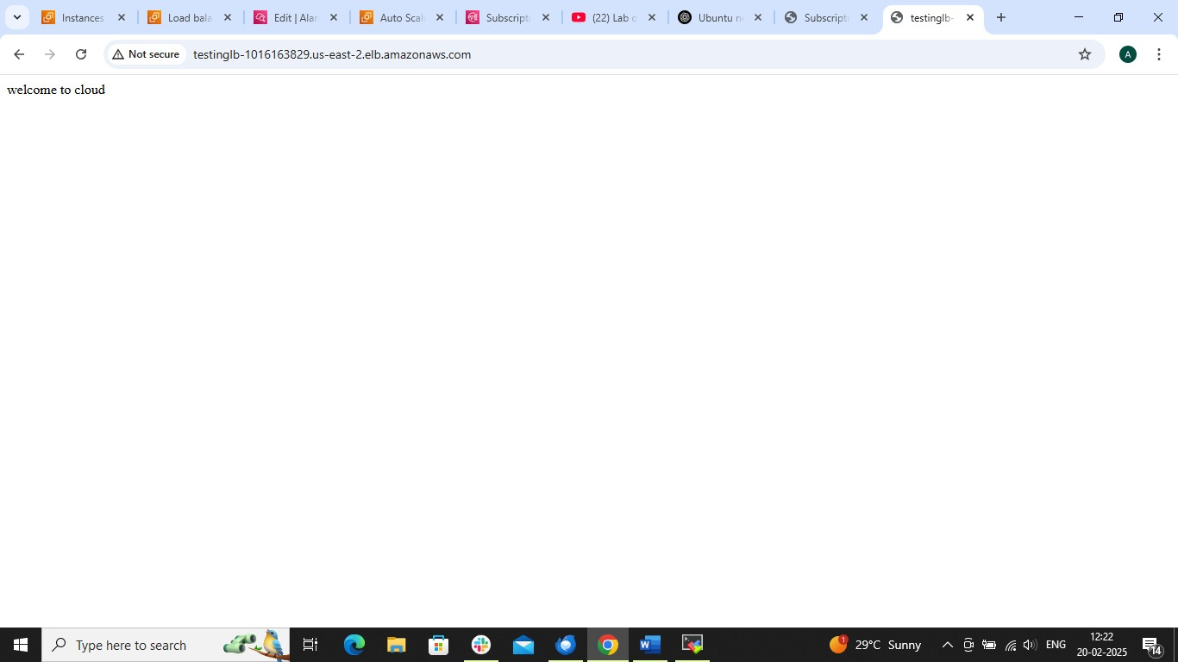

TILL NOW WE DID SCALING BY TARGET TRACKING

HOW TO DO SCALING BY STEP SCALING POLICY AND CLOUDWATCH ALARM

GO TO ASG 🡺SELECT ASG 🡺AUTOMATIC SCALING 🡺CREATE DYANAMIC SCALING POLICY

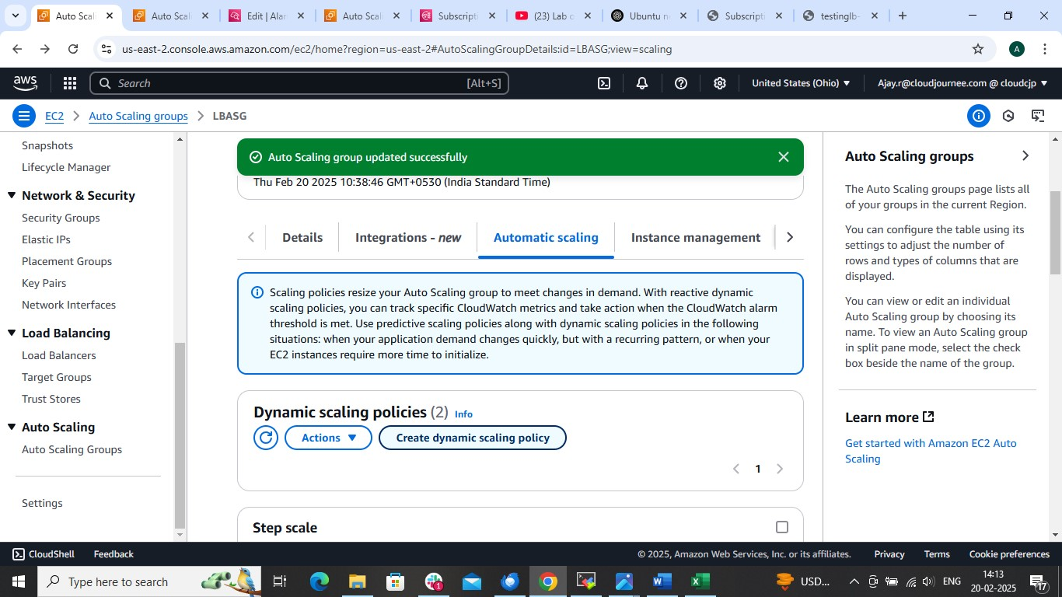

CHOOSE STEP SCALING AND GIVE NAME AND 🡺CLOUDWATCH ALARM

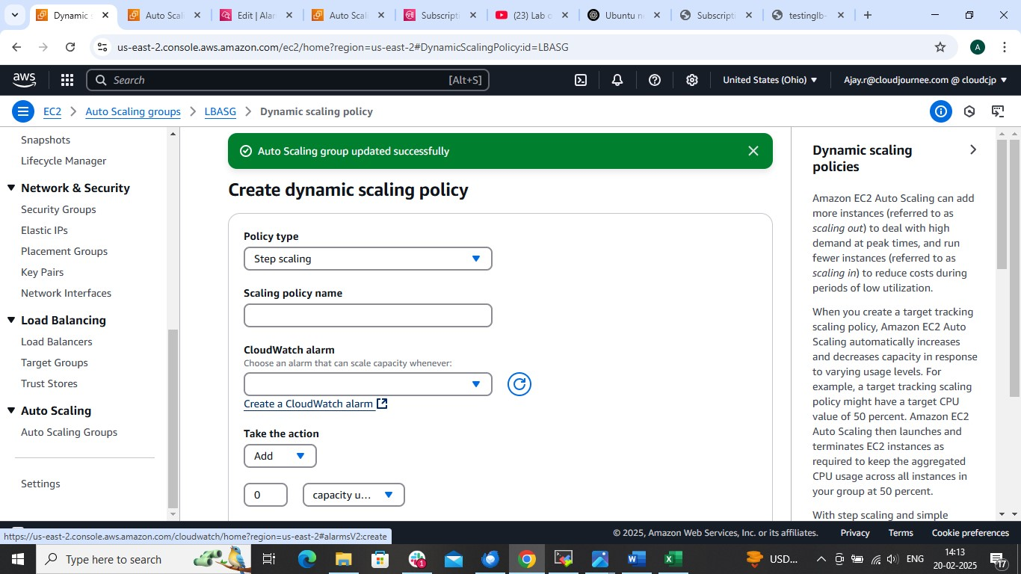

SELECT METRIC

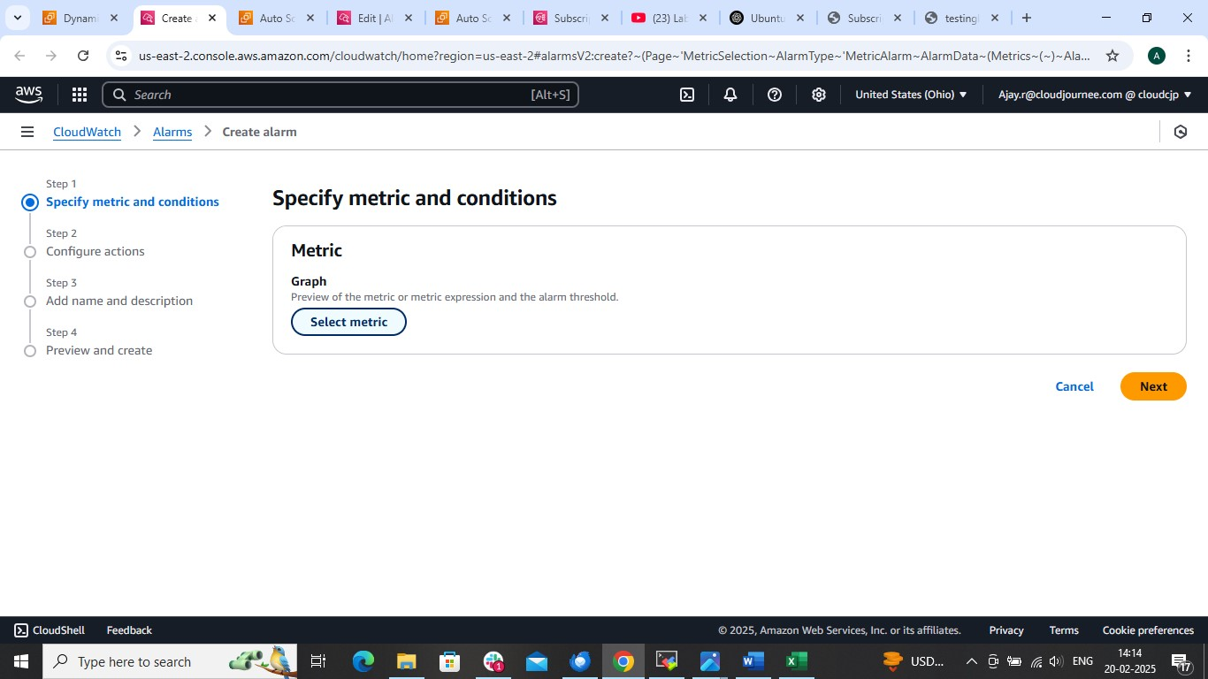

IN BELOW PAGE

From Line section we can choose any type of diagram like BAR, GUAGE , ETC

🡺EC2

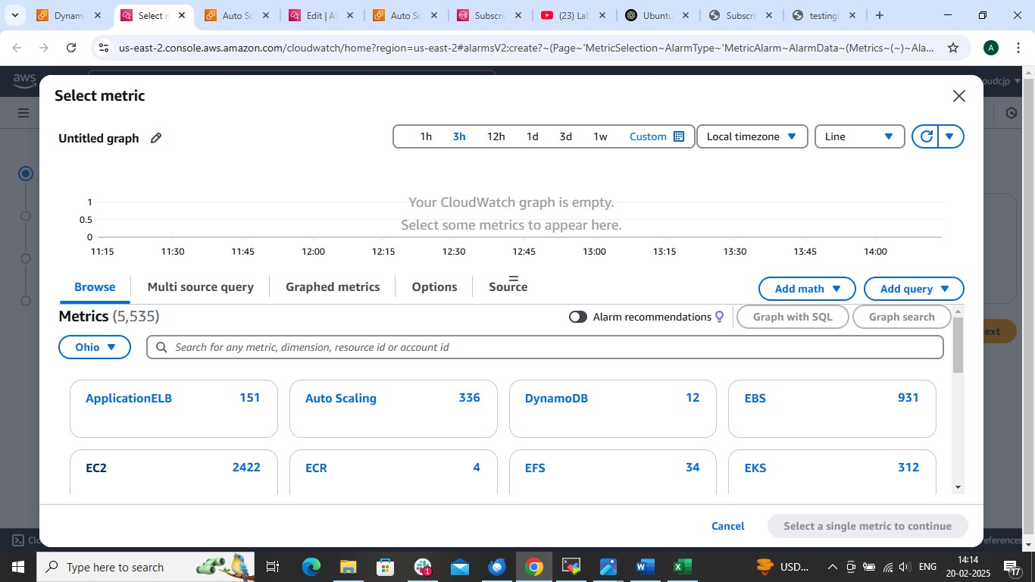

🡺By auto scaling group

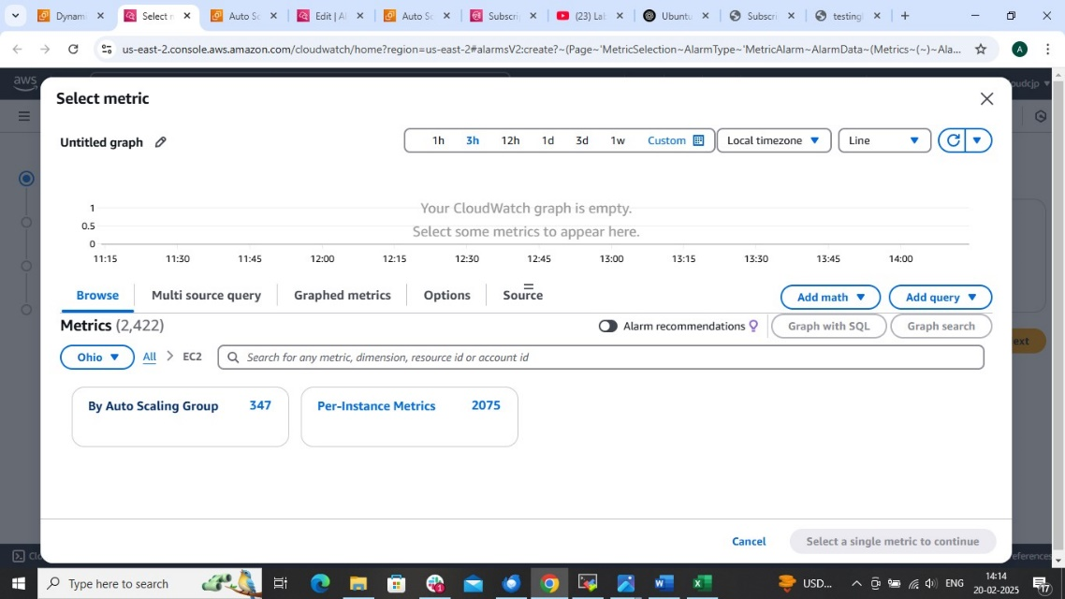

SEARCH load balancer autoscaling group

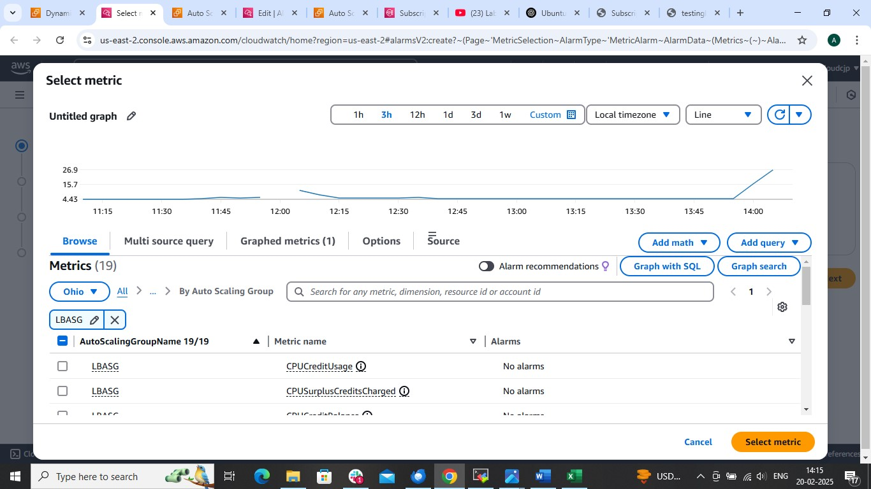

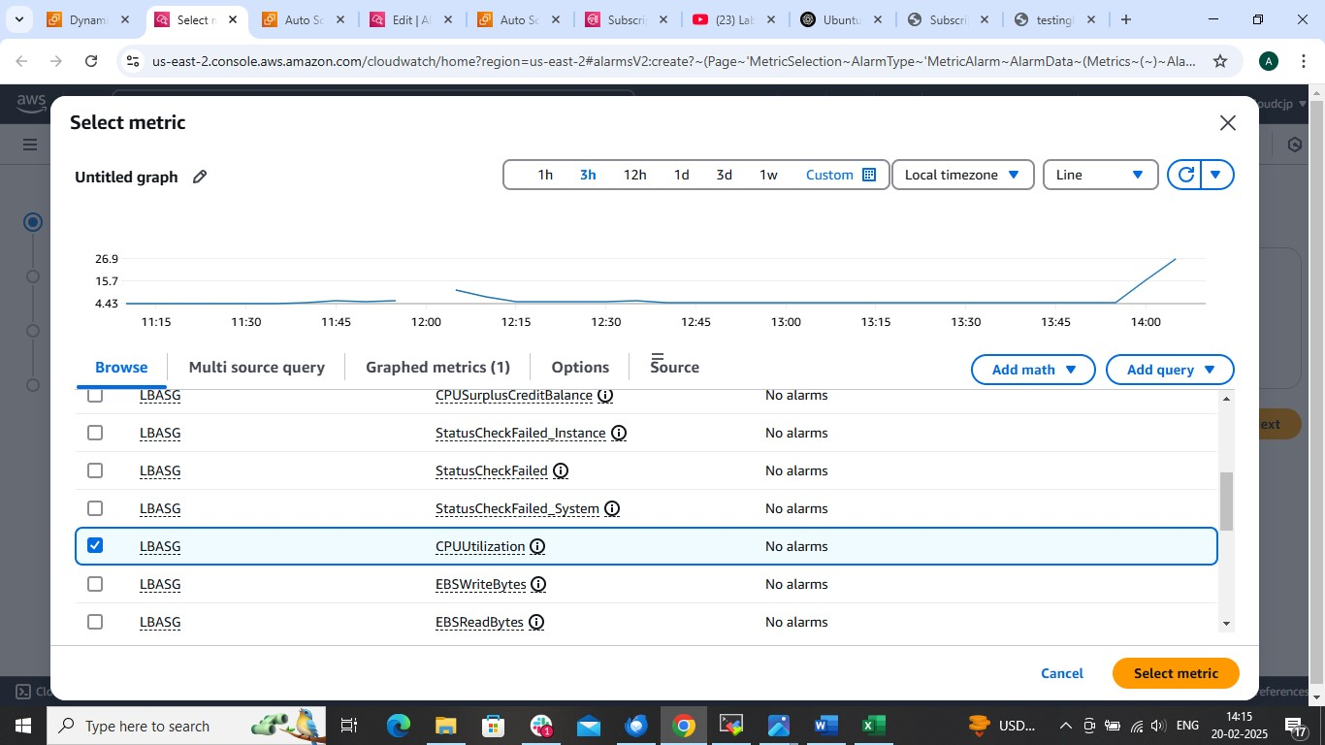

🡺create

REVIEW

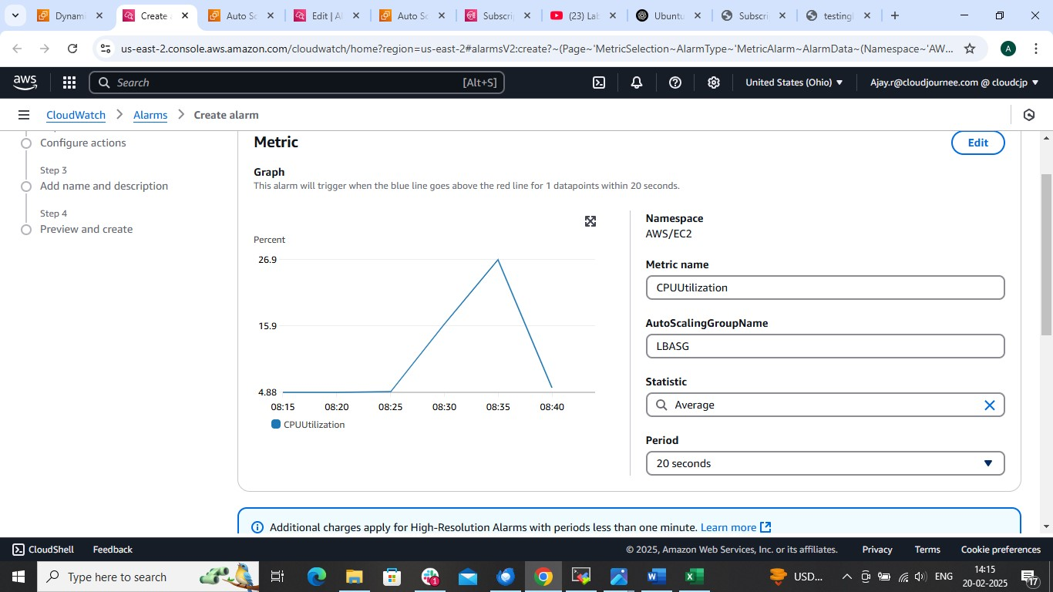

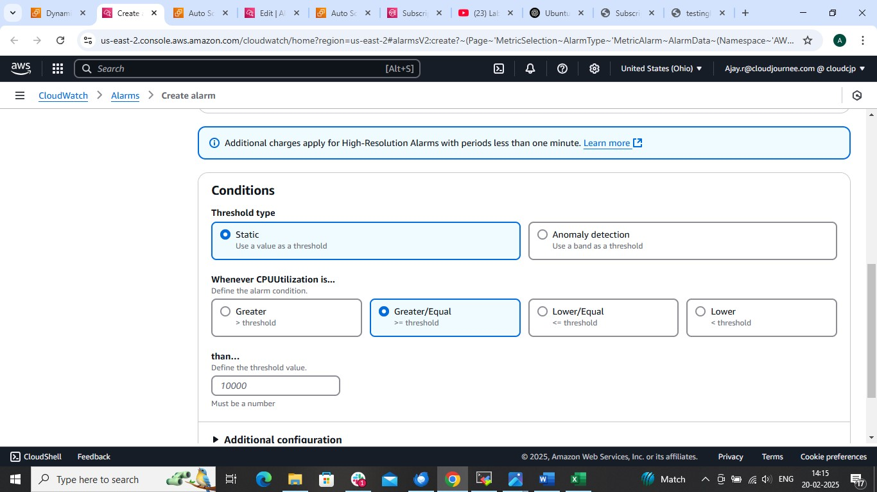

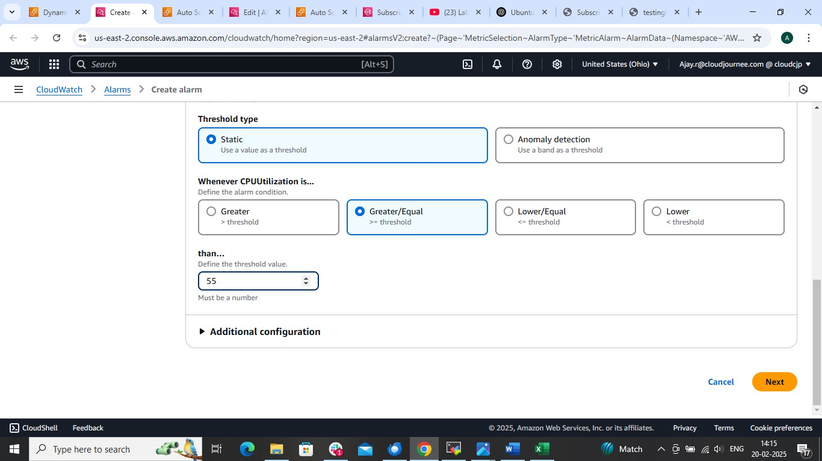

🡺create new topic and give topic name and mail id 🡺create topic

And select topic ..

Go to mail give confirm subscription

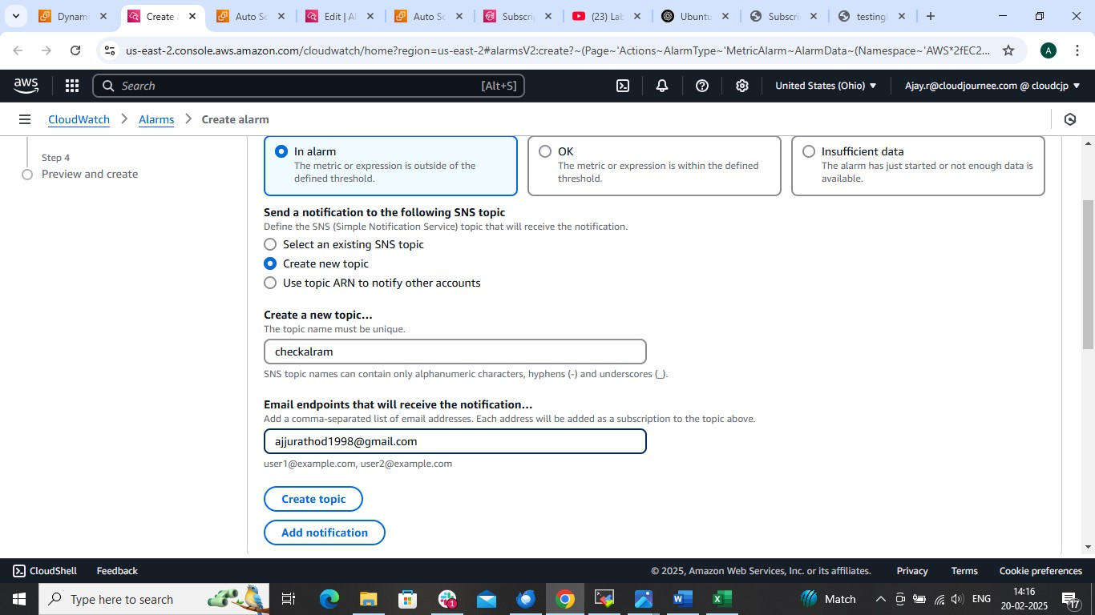

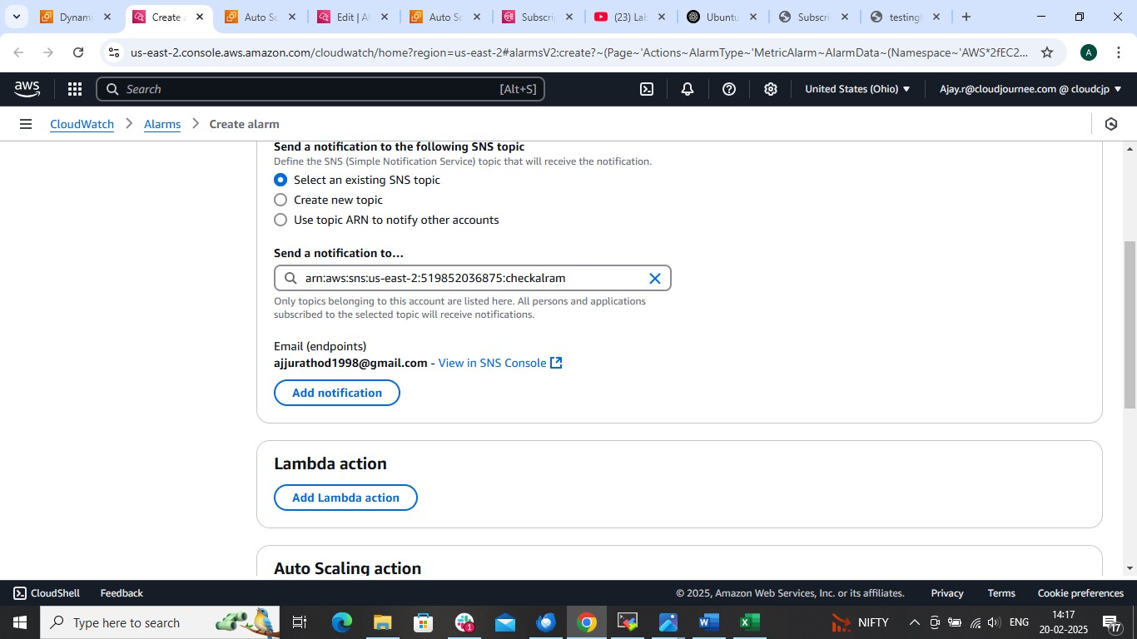

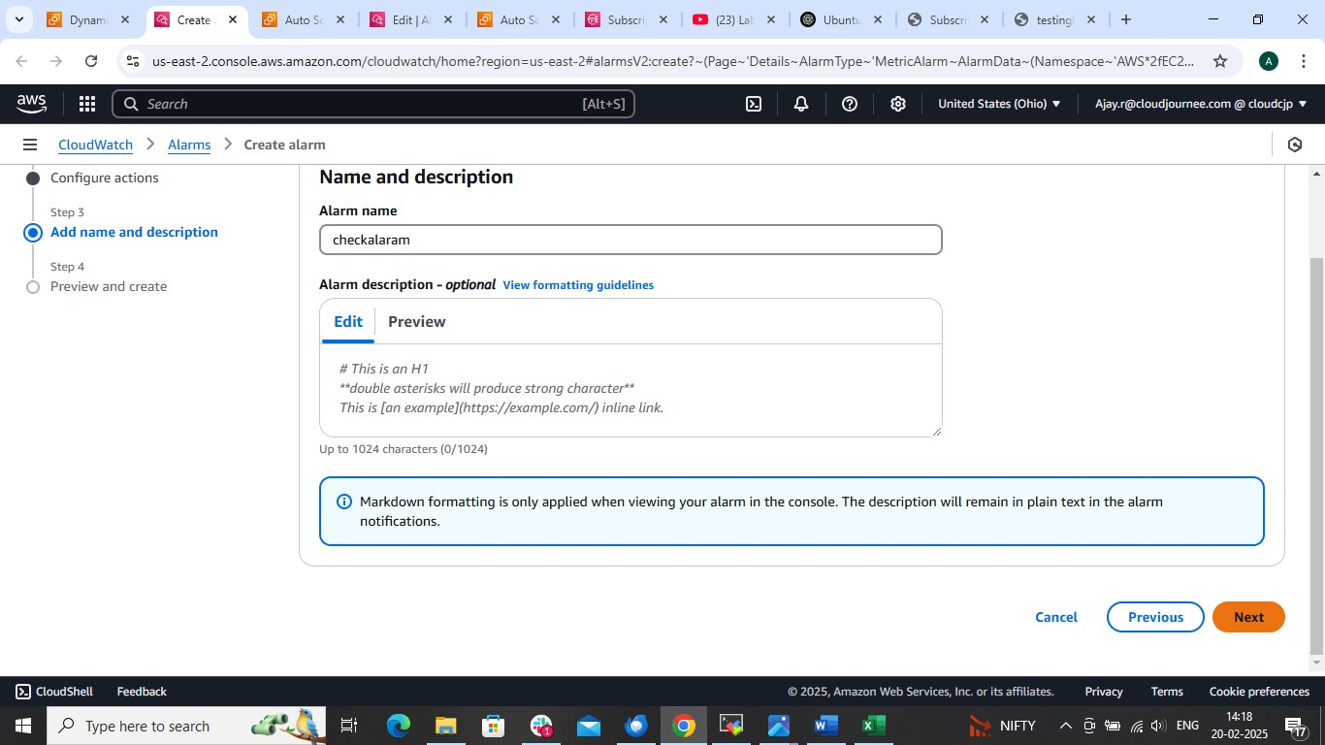

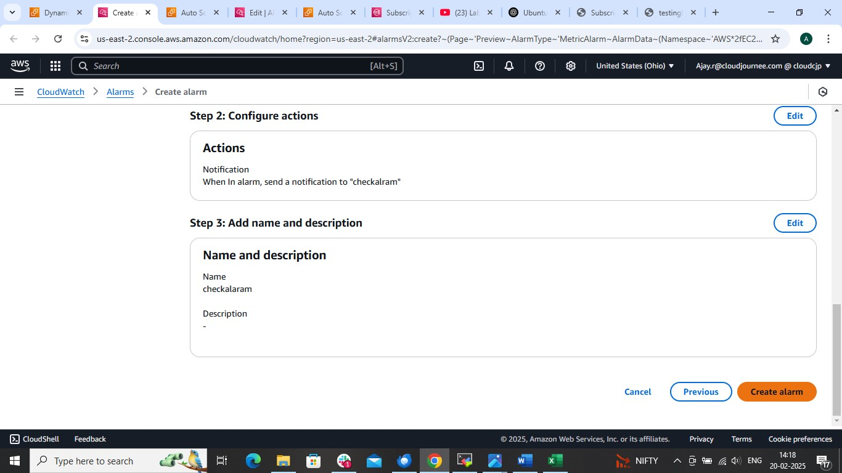

AFTER CREATING ALARAM NOW ATTACH IT

Now to 2 add instance if CUP utilization > then 60

And add 1 or (3) after cpu utilization > 70

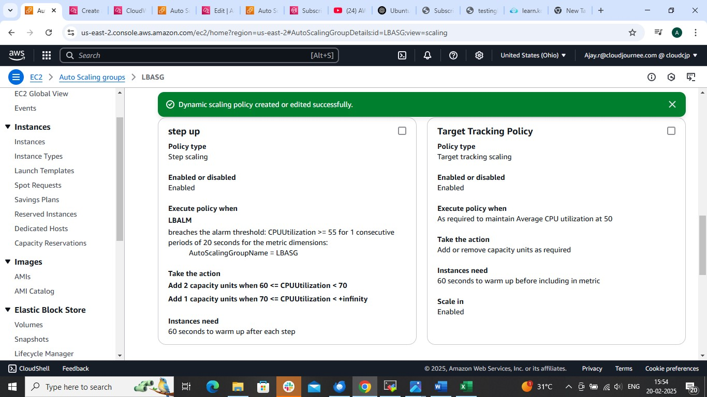

To remove instance if cup utilization is less than 30

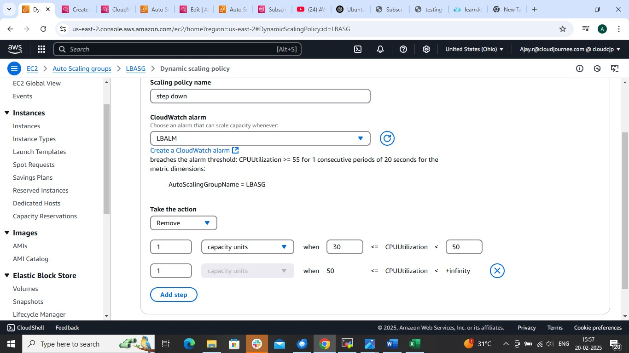

That it